The Crucible is based upon the 17th century witch­ hunts that took place in the community of Salem - a small religious colony of Puritans near Boston, Massachusetts. Miller wrote this play as an allegory to 1950s McCarthyism; it parallels the activities of the House Of Un-American Activities Committee in the USA during the mid 20th century when para­ noia about communism pervaded the USA and spread to Canada. The Crucible is a story of a village overtaken by religious fervor and mounting panic, where people are arrested for being witches with­ out evidence. In Salem, matters of good and evil are dearly defined; dissent is not merely unlawful, it is associated with satanic activity.

Early in the year of 1692, a collection of girls from the colony fall victim to supposed hallucinations and seizures after dancing in the forest with a black female slave named Tituba. Suspicion surrounds Tituba and soon accusations and fears of witch-

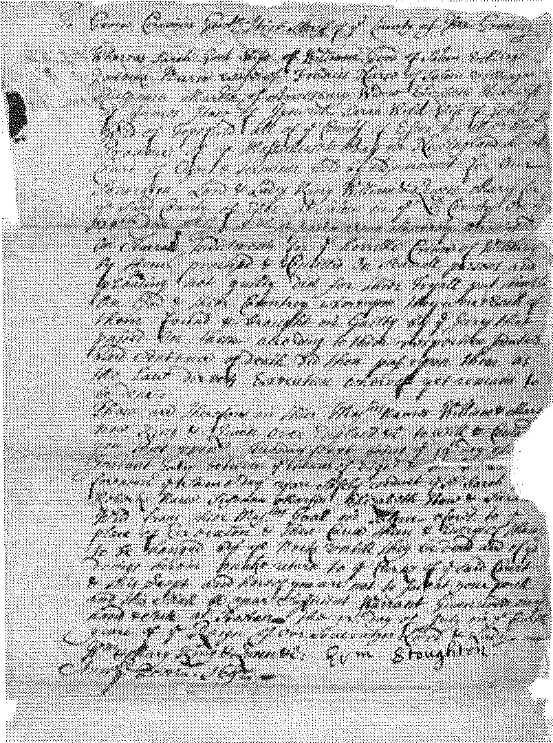
Death Warrant for Rebecca Nurse
(Original court document)
--------------

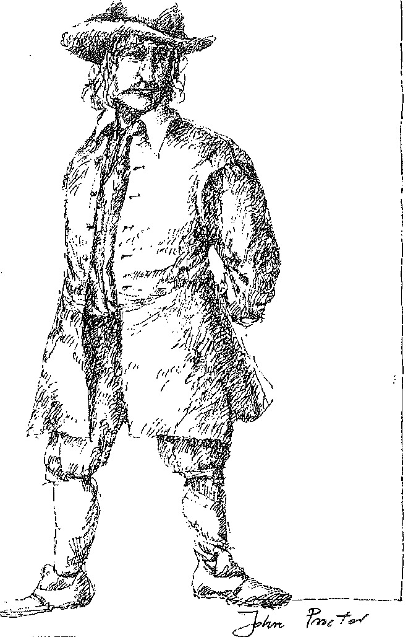1
I
I

I

I
I
\

i
J -

Costume design for John Proctor by Teresa Przybylski.

craft fill the town. Abigail Williams, 17 years old and beautiful, appears to be the girls' ringleader, and when Tituba and Abigail begin accusing vari­ ous townsfolk of conspiring with the devil, the other girls join in. Soon the colony is beset with jealousies, bitter quarrellings, and deeply held ha­ treds rise to the surface. Local farmer John Proctor is a deeply honest man and he suspects Abigail of being a fraud. But Proctor has a guilty secret to protect- an affair with Abigail when she was a ser­ vant in his house. This proves to be his downfall. Jealous and vindictive, Abigail accuses Proctor's wife of dealings with the devil, and as the hysteria grows, Proctor hesitates to expose Abigail in fear of having his secret exposed and losing his good name. Old grudges and religious fervour result in tragedy, as good people are hanged for witchcraft, others are jailed, and a community is left with its conscience in tatters.

ho

At the center of the Salem tragedy were real people- the ''bewitches!" young girls, the towns people who fell prey to the hysteria and the innocent individpals accusl::d of witchcraft; Whether they helped create the witch-hunt or were at themercy of the events, these pe()ple
l:llade·up a community consumed by jealousy, feat, hysteria, superstition and hyPocrisy:·

Abigail Williams, is;il:ormentedcharacc ter .who represents. absolute ev:il and The.Devil. She is the 'rnass murderer'whose actions bring about the death of so many innocent people.
She was deeply in love with John Proctor and now that love has been taken away from her, her vengeance is powerfuL'She wants revenge. Buther lifeis,n tan easy one. She is.an orphan whose parentsweremurdered by the Wabanaki, (seeJ'g. 9); Shhas raised herself, feeling some" what on'\:he edge of society, and observing all the manipul rlori nd hypocrisy around her. Her powe£.comes 'from her intelligence, empathy
arid c ur e, ; he's like an animal, instinctual and str ng. 'sub k ows what she has to do. to
John Proctor is ll.deepl}'honest n, \Vhois t;oubledhy his act of lechety with AbigaiLD£iven, by guilt ; proctor l>e:
comes the .hero of this play, butlie is painfully hwnan. ilis
fall from grace is part of his humanit}'. He is weak rid nd ­
cided, full of contradictions, and }'et he Wakes> herO:i hokes. He .is a man who cai{ be e sily J.Ind r toodbec use he is imperf(!ct.. Part pf this· impc:;rfection is thknowled e that his.. bond \Vith Abigail . is. got. completely ended. His
choites are. difficult butirltlie d:, li rbk

oeputy-Governor•··oa' f'ortl1
nor of Massachu$ett ad the pr sidirij dge at the wit ht#al&: Honest andscrupulo•• l)anf6i'this a tough J?o t61)_Jawr who is basically faiJ:,' qnestand.sc#pul§4s b tove coriE ent
in his abi#ty t() Judgetht:J:uth. fl<!is waYS right, at leastin ·.
his o J.a dii c6 Wnc6 thl!t 11s s ?<t ghti rooiipg.
out wit hcraft. Danfo th feelthatit is his quty. destiny to••
pt;ll:gec ciety of evllarid establishth gdirnpf''ciu:i tQ <
ai'th.,fi ·.is, therefore, temperamentally' lf#eu?to.irlietpraill

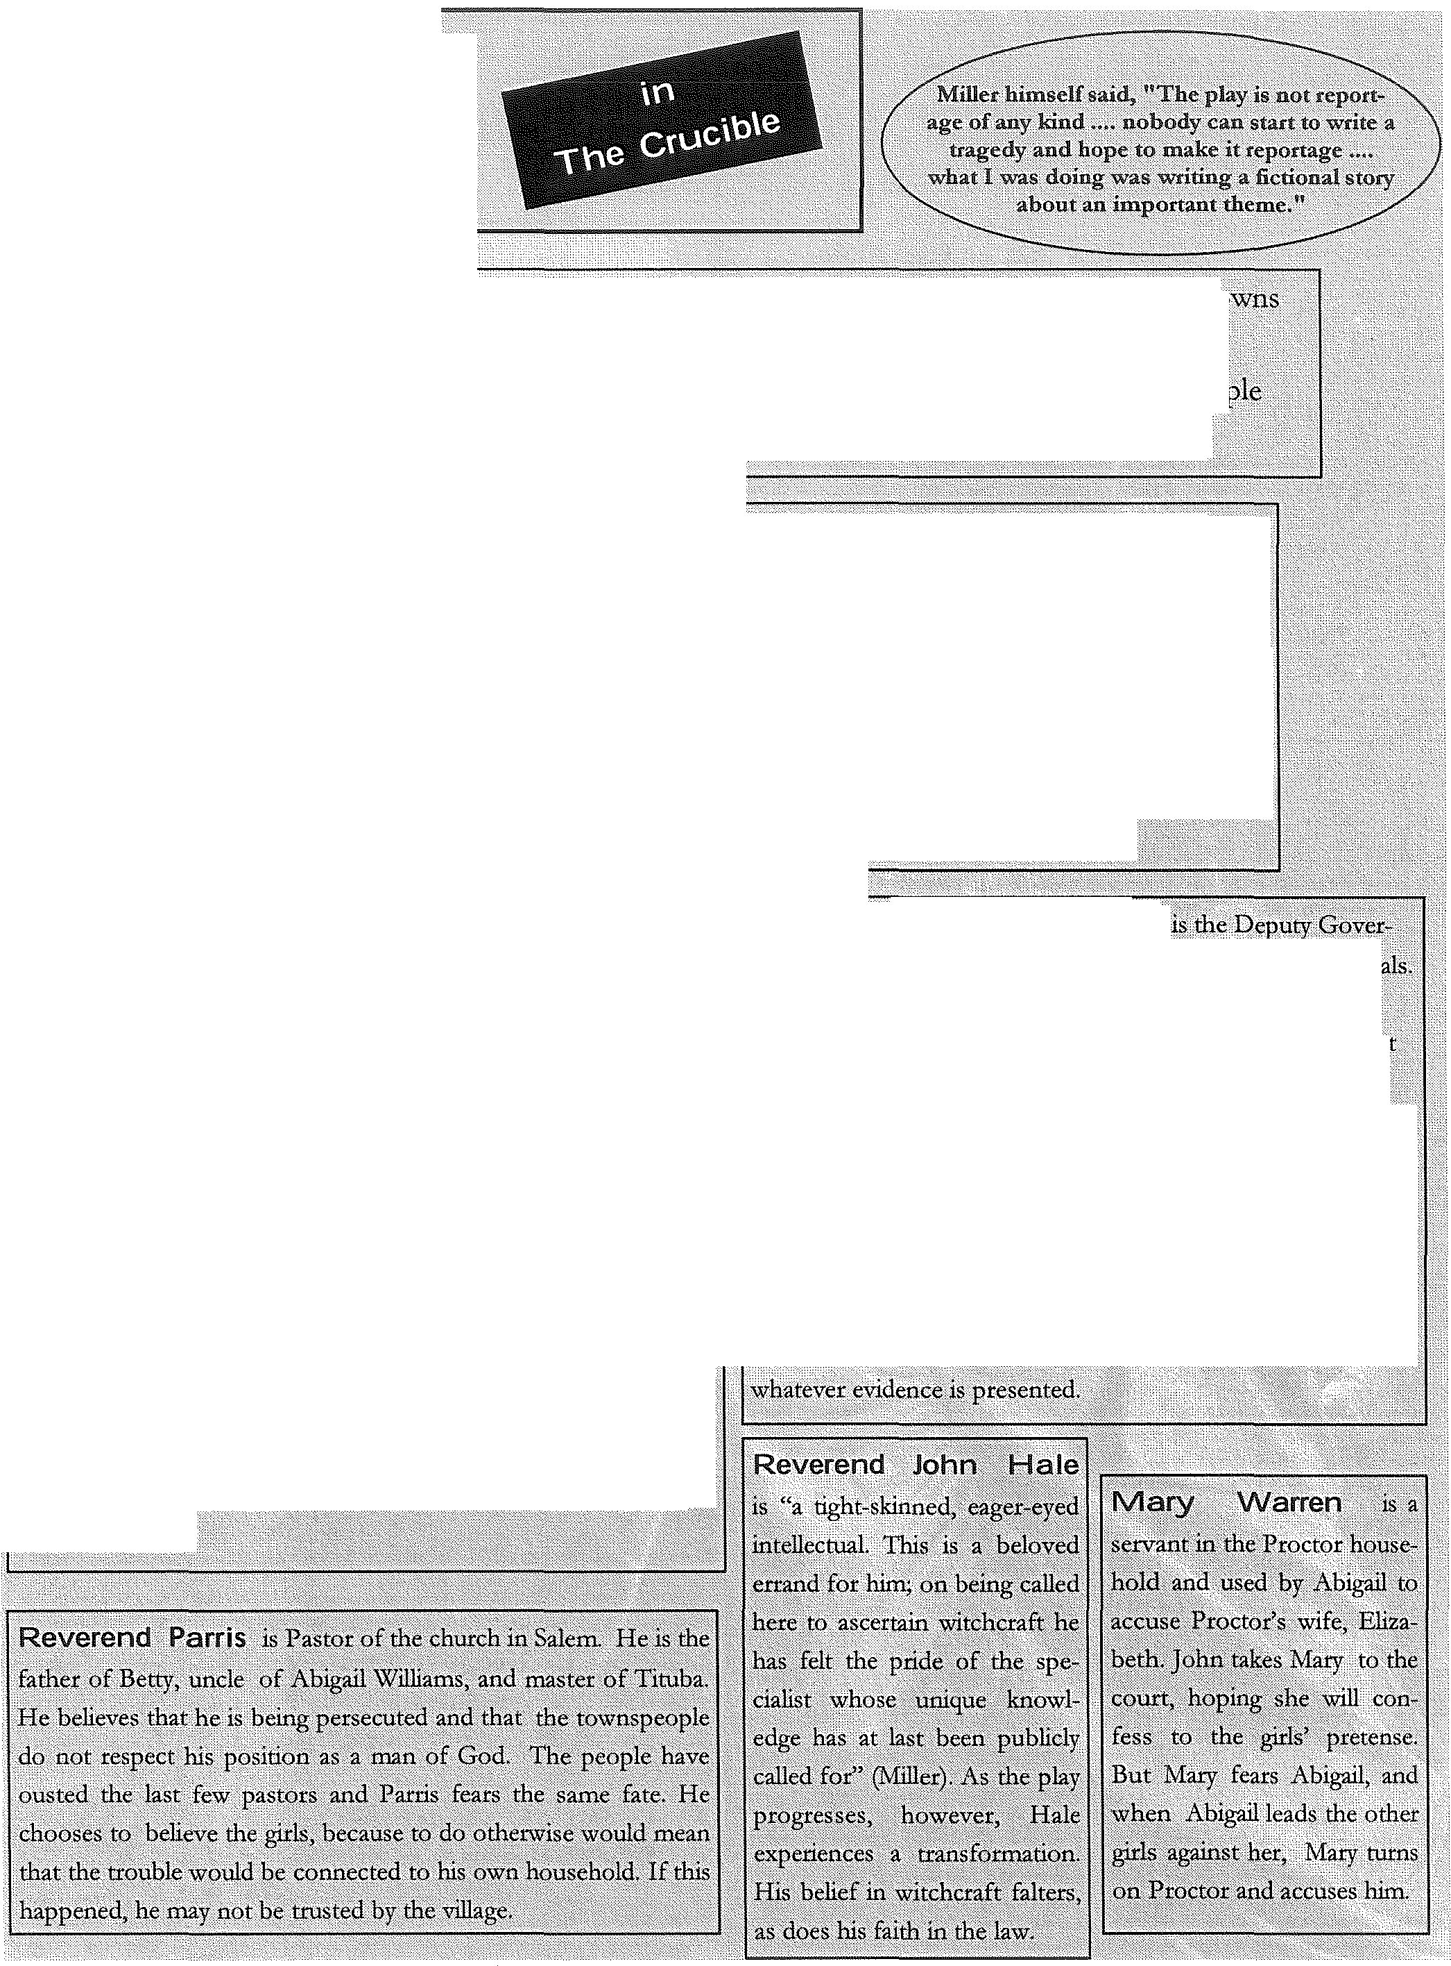Elizabeth .Proctor )s a go()aiw61-UaB:,who ):la;; peep treated
1Jadly ad sh pays· the ul rice.H riove·· ct\m et tanding
of her .h\1sbandJohnis powerf ,::b:ut 1£ slw accepted his lidultery, she did tibt intend to let itconthiue. She'is n() foolad der stands Ab1gall's intentions well, qeftJr:.tbarii>Ibctbr hlmsel£ She
lllovingtnother,(Y ·iS sept t() p o'ri"e, entl!origshe qtrrie cl:nHShe is· described as l) ingc()ia, but isp aP,s ere,ly acce,ph
ingbflierllf \.•·
evide!lcs proof that Satan's forces are op rati g i¥}a1e;
seems to feel patticula,ily s!:fRP.gly that the girls honest He .·
is sensitive to thepre;;e c :()f the. deVil:and reactJ xplosively.to

Arthur Miller's classic parable of mass hysteria draws a chilling parallel between the Salem witch-hunts of
1692 - "one of the strangest and most awful chapters in human history"­ and the McCarthyism that gripped America in the 1950s. And yet, when read from the perspective of over half a century after the play was written, its
core message seems today to be far
r ·- ···----- ·-·---.. - --·----- ----------------.. accusations have repeatedly scythed
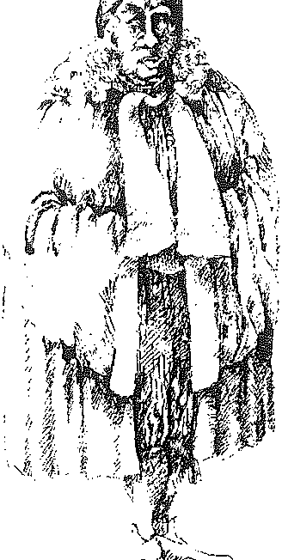i
their bloody crops. Miller's comment on
his work, written in 1953, is striking:
''When one rises above the individual villainy displayed, one can only pity them all, just as we shall be pitied some day. It is still impossible for man to organize his social life without repressions, and the balance has yet to
be struck between order and freedom".

more universal: analyzed in The Crucible -

c-.:.:...L

-"=·' -
I remain particularly touched by the

are not only those two particular
Costume design for '_:,,,.,, '"'" deep, understanding humanism of this
Danforth by Teresa Przybylski.

moments of American history, but also play. ''What is man?" asks Miller. Look with
some general, fatal pattern of human behaviour, no illusions, he seems to say: these two-legged repeatedly re-occurring -like a disease - through monsters seem capable of every possible evil, every
the centuries. Salem-like witch-hunts happened- imaginable cruelty. And yet we humans -wretched

and still do happen- in many places in the world. Innumerable communities and whole nations have been stirred into madness by superstition, malice, and ideological paranoia. The evils of mindless
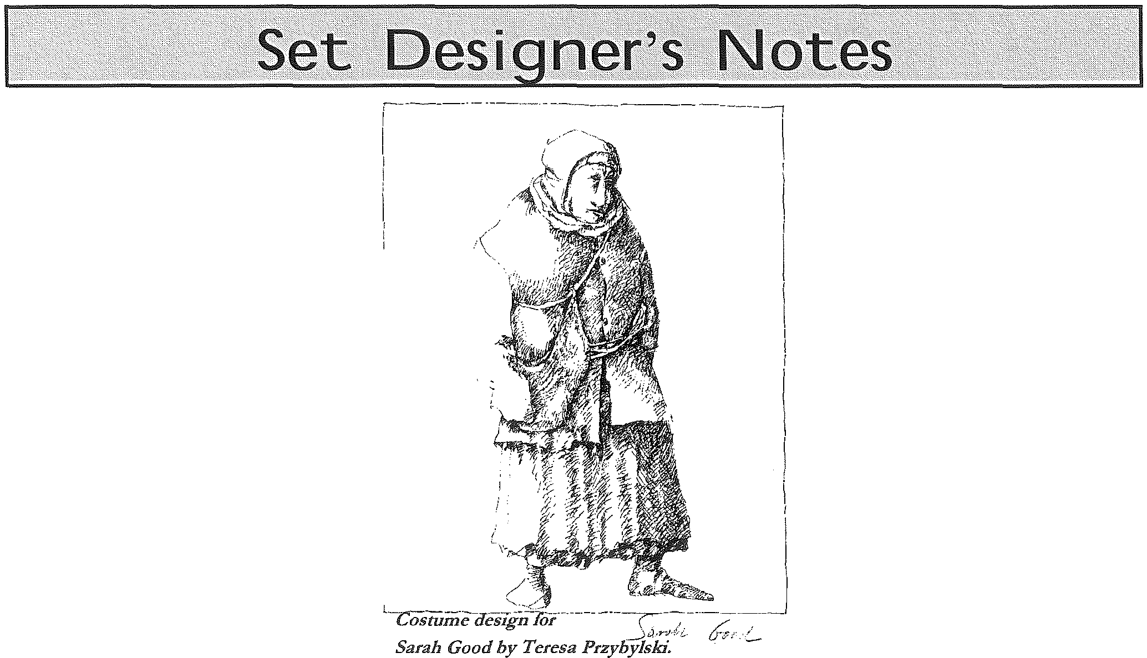persecution and the terrifying power of false
creatures in many ways - are able to reach almost angelic levels of goodness and beauty, thanks to the unique human treasure we all possess: our free will.
Tadeusz Bradecki, Director

Strongly rooted in its historical time frame of 1692, director Tadeusz Bradecki and designer Peter Hartwell saw the set design for The Crucible as reflecting a
metaphysical space in keeping
with the sense of the play as 'a i
\
\
parable'. A large black grid dominates the stage, rotating on its axis to form a horizontal floor or vertical walls to create four different places of action. Each rotation is accompanied by the sound of metal chains and grinding machinery. Says Hart-
well: "It represents the eternal machinery of human madness, like some kind of gigantic guillotine, pushing us from one place to the other." And the backdrop is a cyclorama of a vast forest, reminding us that the wilderness, the ever­ stretching American continent, was never far away. The large black strip running along the backdrop echoes the long, rec­ tangular windows used by the media to view the McCarthy hearings in the 50s.

Be wa a,{'!at playwright, a great man, and a man
of rare iritegrityin/Jit writing. Hi was a landmark
2005

Arthur Miller transformed American theatre. Following the erid.ofWprld War II; he tapped mio 9. 11s of dissati::;faction. and unrest within the greater Americanpsyche. His dr as::W:bre provocative, insightful ang
probing.·He B came the 'public conscience'. Regardeda brilliant \.V tet, ,s Jlllch:nwna J;arian,.a d imatl
ofg7eat dignity,.it is said that not a day goes by when one 6f1viillet's phtysis not ein /P: tfP fped some h r
in the wo.cld.

AlllviySons (1947), Death of a Salesman (1949, won the Pulitzer Prize), The Crud bie(1953),,4 View from the Bridge{1955),
--....-- ""'-'-----.· PaJ;ehtscJe s imrnlgtahts,I i re and At;gust:l. J\1l)ler . < ....· . ·. F:1,ther:·a lacUeswe:l,r m nl1factw:ei. .. Mqthet:.a $f ()Ol eacher housewife.
•.• attte sJoari.(:opfl m.d. . .
and
IPl:oo::J.er:. Kertnft.. ·

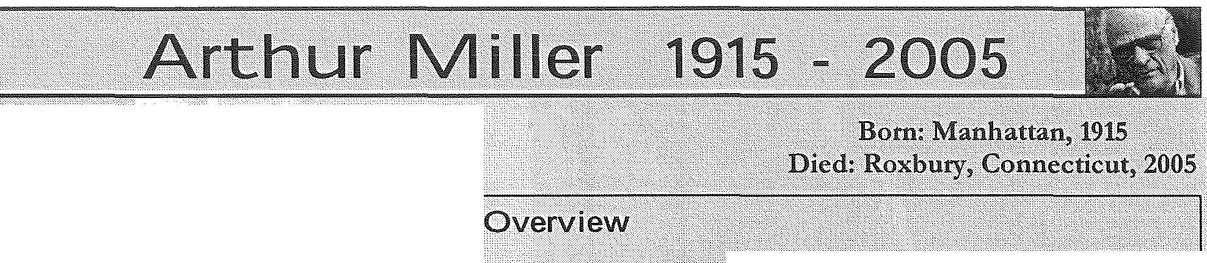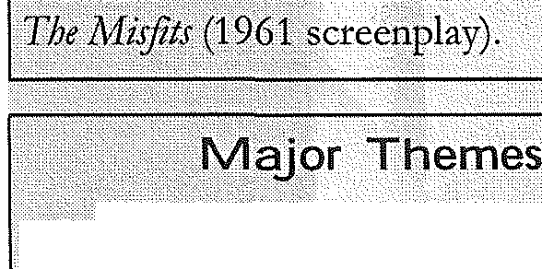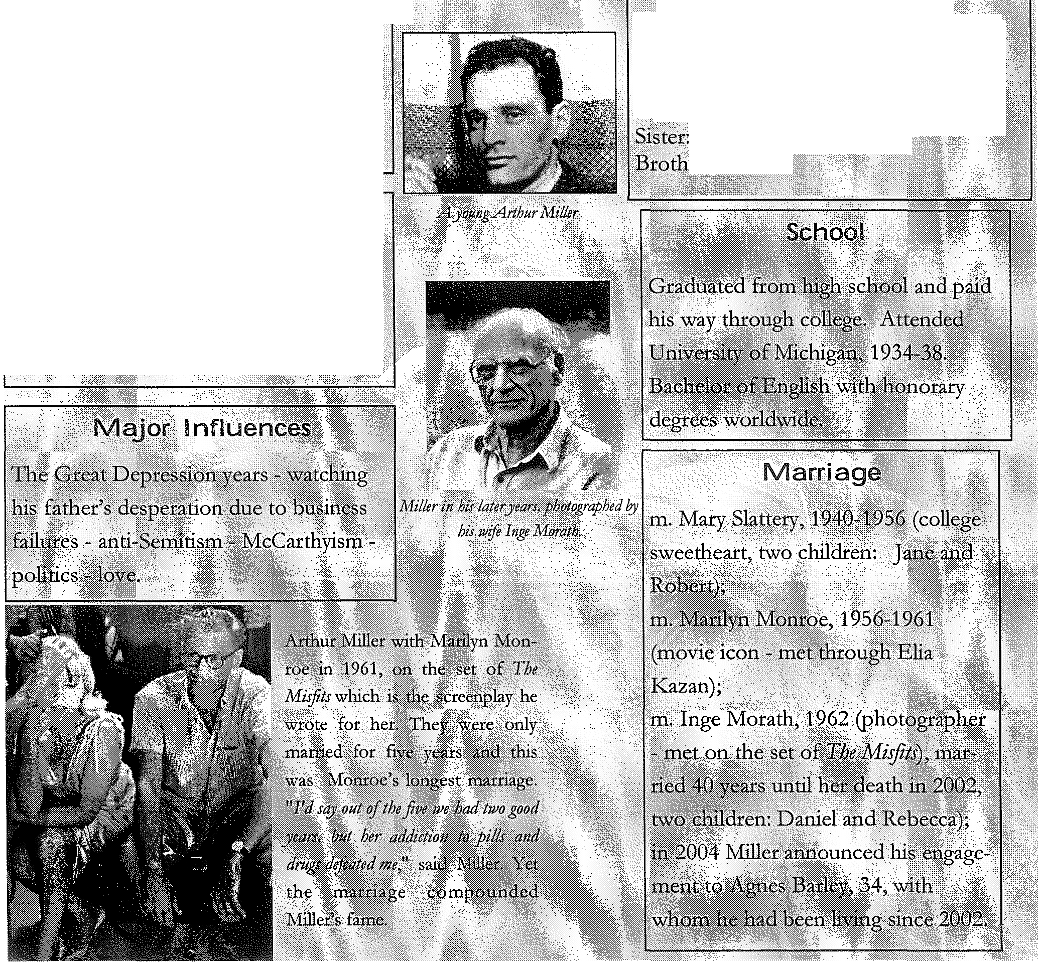

Mo:ral plight()[the working dass - moral
resporisibili :-struggles ofc()nscience-
"; ·' .
.socippolirical coinmentaries- betray9.1:..
deat:l£- injustice.

Seeking reprieve from the strict and narrow ways
of Puritan life, several girls from Salem secretly met in the woods to hear the exotic tales told by Ti­ tuba, a slave from Barbados. In February,1692, the Reverend Parris discovered the girls participat­
ing in one of these forbidden sessions. Afterwards, Betty Parris and others began having 'fits' that de­ fied all explanation. Doctors and ministers watched in horror as the girls displayed catatonic symptoms and signs of the devil.
Unable to find a natural explanation, the Puritans turned to the supernatural - the girls were be­ witched. Prodded by Parris and others, the girls named their tormentors: a beggar named Sarah Good, the elderly Sarah Osburn, and Tituba her­ self. Each woman was in some way, a village out­ cast.
Tituba claimed, "The devil came to me and bid me serve him." Villagers sat spellbound as Tituba spoke of the devil's mischief and how she was co­ erced into signing the devil's book. She said there

"King William's War" or "The Second In­
dian War"
were several undiscovered witches who seek to destroy the Puritans. Discovering and eliminating witches became a crusade- not only for Salem but all Massachusetts.
In June of 1692, the special Court of Oyer (to hear)
and Terminer (to decide) sat in Salem to hear the cases of witchcraft. Presided over by Chief Justice William Stoughton, the court was made up of mag­ istrates and jurors. The first to be tried was Bridget Bishop of Salem who was found guilty and was hanged on June 10. By October of that year, thir­ teen women and five men from all stations of life were hanged before the court was disbanded by Governor William Phipps. A new court, (the Supe­ rior Court of Judicature), was formed which did
not allow spectral evidence. This belief in the power of
the accused to use their invisible shapes or spectres to torture their victims, sealed the fates of those tried by the Court of Oyer and Terminer. The new court released those awaiting trial and pardoned those awaiting execution. In effect, the Salem witch trials were over.
The Wabanaki Confederacy was a coalition of
five Algonquian tribes of the eastern seaboartl banded

In 1689 the English parliament drove the papist James II from the throne and replaced him with his daughter and her husband, the Dutch Protestant WilJiam of Orange. Ongoing tensions between the Fr nch and the English
contributt;dJ?. olonial conflicts. Both competed for control of the Maine frontier. The people of Salem.feared attacks by the French/Catholic
ba Jit:d>W banaki Indians with whom there had been an uneasy truce since ChlefMetacomet's War (1675-1678). Thecolony lacked a constitutional government, and wealthy men had soakedup.the power and put the judici­ ary in disarray. ''The times were out of joint," wrote Arthur Miller. Feuding Landholde s
Salem villagewas rife with resentment and rivalry fueled by disagreements over land and taxes. A race for land-wealth pit neighbour agains.t neighbour. Accusations weremade against known merchants who ttaded arms and food for profit t() the French-allied Wabanaki Indians. Many ()f
the accusers resented this, djle to loss of family members and landh ldings.
Those merchants were seen as traitors, having 'devilish collaboration' with the enemy,
together in response to Iroquois aggression.· yc:;·, • ;
U.ke other Wabanaki tribes, the Penobsl:oti df ns of Maine were longstanding enemies of tb;Iroqdo{ patticular!J the Mohawk. This led thetn to sidi!Vith. ·
the French and Aigonqt ins inthe co; !Y war against the English andlroquoians. The English paid out bounties for dead Penobicots, butit wa.s!3uro t{n disctt.fes (especial!J smallpox) thatrcalfy decimated. their nation, killing at/east 75% of the population. Still angry with the British, the much teduced Penob­ scot tribe supported the Amen'cans in the Revolution­ ary Wat$ and havingpicked the winnt'itg sidethry were notcXpeJlcd from New England, and to.this dqy, remain on f¥SCt:Vations in their tt'atiiJP.Maine. Recent!J the Penobscot tribiwas able to bl!)l back some of their ancestral lands, an.d today thry at¥ a
sovereign nation working to maintain their traditions, language; an.d se!fstiffidenfY.

. -
peftPrion:Crucible.(n) < , .._
1. A severe tesft.as'!{patience or beliif; a.irial:
;.A place, tif!1e,·or sitf{ation.fhdrtJcl!rizebdy.the co ence of
PQUier,foJlntclkct; a4 socjaZ eC(}itomic, politicalforccs. .
:3.:4 mptaltr;t tainer: ffst4 to heatm'ltcrial to a wry bigb
.·• . ·· ·temperature. · ·. ·· . ·
4.A /JQ//ow area at thli bQttom oftfomace w/Jei-p; ctq/
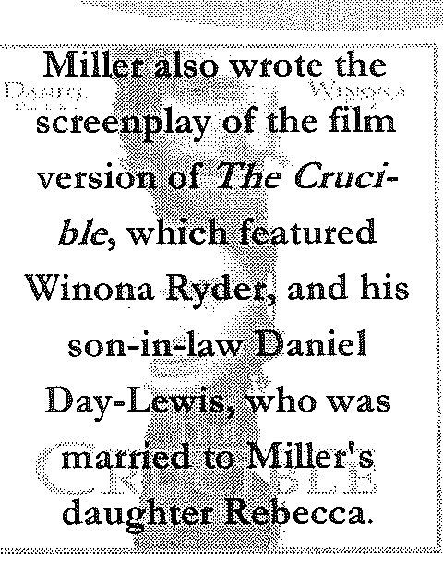. · collecir ·

l)ll) YOU IC1\lOW

,,;;--:;, ,'/'
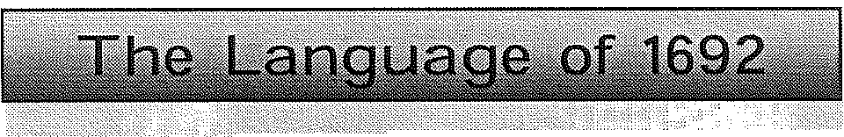Miller used th.l ·. _ .-. qf language in The Crucible t?
help .cr ate the to ·of.t{century Salem with dia:­
lectdioices imbedd din the scrip. He chose a rustic,
coll()qcial sound;partly baseq on Salem records, with
echoes of theil<Gng]flilles bi le; not uclike a dial e :;t still heard today in fuJ: :&o9-th.ern England. 11illet
achieved his effect bychangingverb tenses, linking
wo ds unusually>afid.l:Jy th(! useqf archaic words arid d9ub.le negatiy¢s, (e.g.. 'i:lqt'.With .'n:o', or 'never').

.'Yo :-;h uldsu nQw thai.cain were an upnght man, and yetJJ .tfiq";killAbel.!! (Parris, ;Act 3);
"He caf!it()t.disf(Juer tio medicine for it in his books."
(Susanna, Acf1);,-:y. · ·

(')ld:-fashioned wprds set e. tone from the be :­
nlng: id.for 'told', unnatural€or upernatural: witche;d
for beWitched', .Pq't for ' ; nq nqy for yes an4
no'.Andas P?:fitans, the ch act(!rs often quote or
allu4 to th(! J3i l hich Mille(\lses () remind us of
th ; trictreligious c9de they.lived by:

'zibt'gail/nngsfh"e:() h;rgirls intoih ·cou"'. and where she •
walkf:thil crowd wilrpartlike the sea for Israel.' (Elizabeth,
Aet2) .. .
youshotjldsure!Jt know that Cain were an upright man, and yet he did killAbei.'Q?arris,Act 3).

Arthur Miller: At a certain point, the. highcourt of the province made the fatal decision to admit, for the first time,
the use of "spectral evidence" as proof of guilt. Spectral evi­
dence meant t atif swore that you had sent out your Jamiliar spirii.' tochoke, tickle, poison me or nry cattle, or to control thoughts and actions, I could get you hanged unless you confessed to having had contact with the Devil. After al4 on!Jt the Devil could lend such powers of visible transport to coifederates, in his everlasting plot to bring down Christianity.

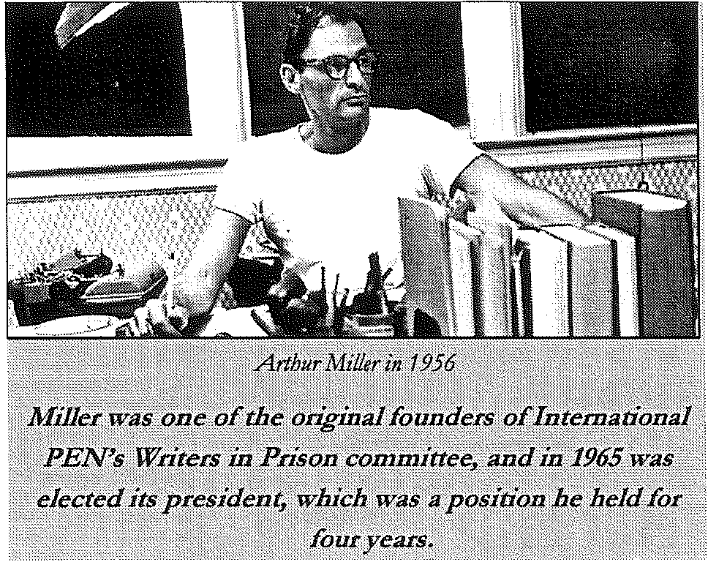

Arthur Miller on writing _The Crucible:
The Crucible' was an act of desperation. Much of JJIY des­
peration branched out, I suppose, from a typical Depression­
-era trauma - the blow strucon the t(lind l:ry thrie of European Fascism and the Grutal anti-StJJnitistn it had brought to power. But l:ry 1950, when I began to think of writing about the huntfor Reds in America, I was moti­ vated in some great part l:ry the para!Jtsis that had set in
among ma'!Y liberals who; despite their discomfort with the inquisitors' violations of civil rights, were ftaifu4 and with
good reason, of being identijied as covert Communists if they
should protest too strongly.

The Puritans split from the
This map shows the locations if mcyor landmarks,farms, land grants, physical features, and the dwellings ifprominent and important residentJ in Salem 1692.

form a religious community in

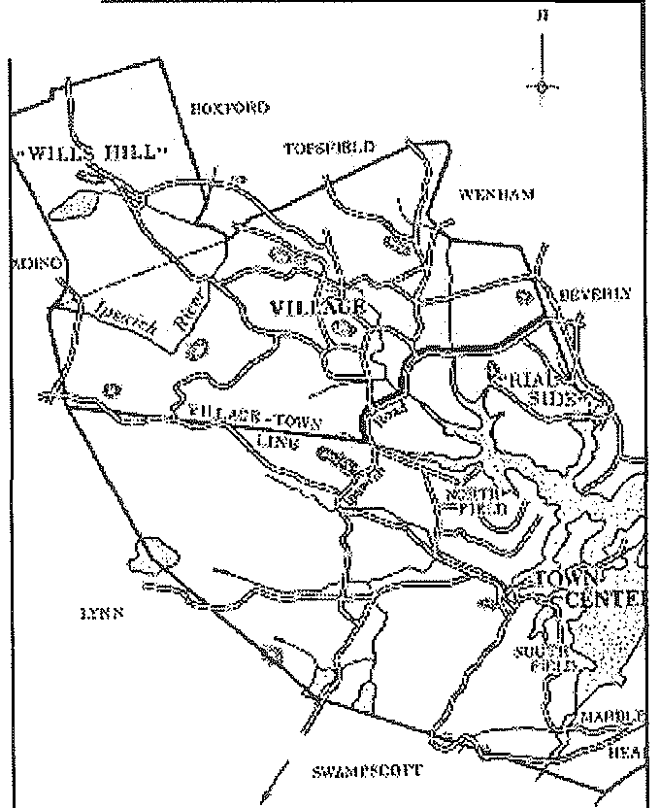Church of England in 1633. When William Laud became the new Archbishop of Canterbury, the new beliefs he brought were unacceptable to those members who sought to "purify" the Church.

The Puritans: Five Basic Beliefs
Total Depravity: By virtue of the original sin of
Adam, when one is born, he has no right to salvation. Unconditional Election: Some are chosen for salva­ tion, some are not. There is nothing one can do to change his status.
Limited Atonement: The extent to which one can
please God with acts is limited.
Irresistible Grace: God showers one with a quality of
grace, and one cannot resist it.
Perseverance: Once one has been saved, nothing he does will change that fact.
These central beliefs, along with an extreme emphasis on preaching and the laws contained within the Bible itse!f
formed the strict ideals of American Puritanism.
which their "pure" ideals could be central. The radical beliefs of the Puritans flourished in the New World. By keeping a strong connection be- tween Church and State, the Puritans were able to control most of the colonies' activity until the end of the seventeenth century.

1-=l.ICNP.Jt

ll..l"B(l-.9'l.-!llt
l'imilcr.

SALEM IN 1692
TOW:>! & V!LLA()ll:

Scholars have been writing about the Salem Witch Trials for three hundred years, with various theories as to wf?y the girls 'cried out: Sexual repression, a male dominated soci­ ety, fear, intolerance, an austere religious doctrine have all been suggested. Here are some findings through the centuries:

17th Century: scholars believed the accusers were actually possessed by the devil and operating as witches against the Christian community of Salem.
18th Century: religious fervour and the popularity
of 'extreme conversion' seemed a more likely ex­
planation for the fits and delusions of the accusers.
19th Century: Theories of "womb-centred" female psychology suggested that the girls were 'hysterical, carried away in a collective consciousness'. (This theory continued with adherents of Freud and Jung).
20th Century: Science experts propose that the
girls were under the influence of natural poisons such as ergot or suffering from an encephalitis epi­ demic. Bernard Rosenthal proposes that they were malicious adolescents drunk on power.
21st Century: Contemporary scholarship refocuses
the spotlight away from the accusers to the judges and the larger cultural context of war, making a case that the accusers were traumatized refugees.
The real Abigail Williams was on!J 11, and the real John Proctor was 60, and Elizabeth Proctor, 41, was his third wife. Proctor was not a farmer but a tavern keeper. Living with them was their daughter aged 15, their son who was 17, and John's 33-year-old son from his first marriage.
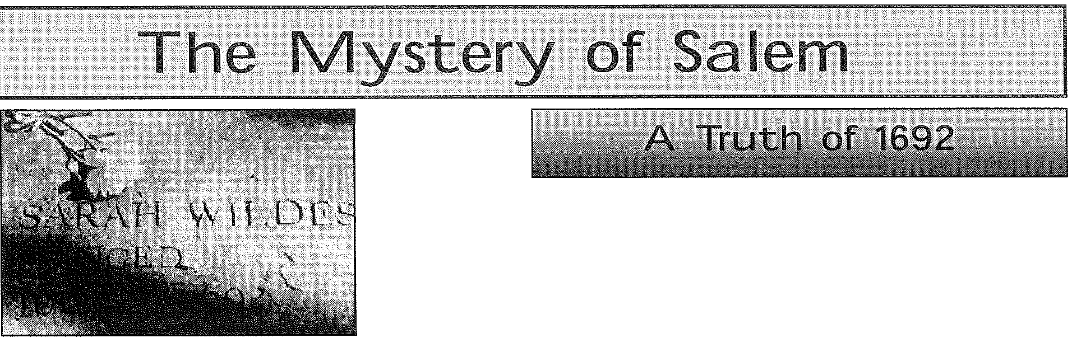Everyone in the fami!J was eventual!J accused rif witchcrrift.
Elizabeth Proctor was indeed pregnant during the tria/, and did have a temporary stqy rif execution qfter convicted, which ultimate!J spared her lift because it extended past the end rif
the period that the executions were taking place.

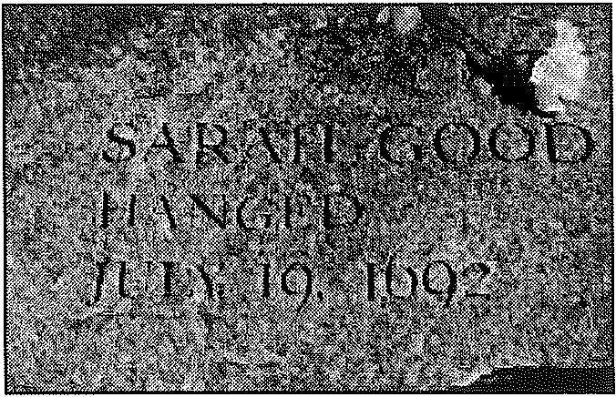

We do therefore hereby signiljr to aU in general, and to the surviving sufferers in special, our deep sense of, and sorrow for, our errors in acting on such evidence to the condemning of any person; and do hereby declare, that we justly fear that we were sadly deluded and mistaken - for which we are much disquieted and distressed in our minds, and do therefore humbly beg forgiveness, first of God, for Christ's sake, for this our error, and pray that God would impute the guilt of it to ourselves nor others, and we also pray that we may be con­ sidered candidly and aright by the living sufferers, as being then under a strong and general delusion, utterly unac­ quainted with, and not experienced in, matters of that nature.

We do hereby ask forgiveness of you aD, whom we have justly offended, and do declare, according to our present minds, we would none of us do such things again, on such grounds, for the whole world -praying you to accept of this in way of sat­ isfaction for our offense, and that you would bless the inheri­ tance of the Lord, that he may be entreated for the land

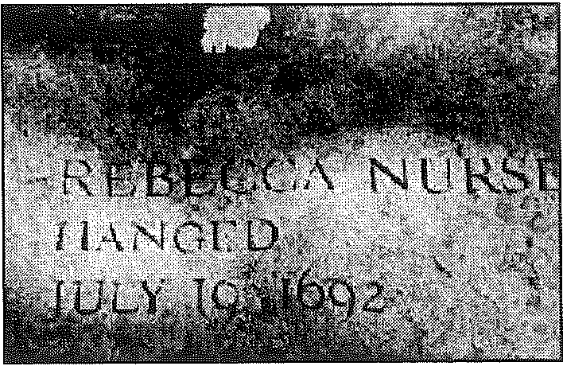Thomas Fisk, Foreman
William Fisk John Bacheler Thomas Fisk John Dane Joseph Evelith
Thomas Pearly, Sr. John Peabody Thomas Perkins Samuel Sayer Andrew Eliot Henry Herrick, Sr.

"Conscience JVas no longer a private
matter b11t one qfstate administration. 11 Arthur lvliller

McCarthy ism grew out of the Second Red Scare that began in the late 1940s and is named after U.S. Senator Joseph McCarthy, a Republican of Wisconsin with a particular zeal in uncovering the 'reds'. Many parallels exist between McCarthyism and Miller's depic­
tion of the Salem witch trials. When The Crucible opened
House Committee on Un-A=erican Activities (HUAC or
(1938-1975) was an inves­
tigative committee, of the United States House of Representatives. In 1969 the House changed the committee's name to the Committee on Internal Security. The House abol­ ished the committee in
1975 and its functions were transferred to the
House of Judiciary Com­

In 1956 Miller appeared before the House Committee on Un­ A=erican Activities. On May
31, 1957, Miller was found guilty
of Contempt of Congress for refusing to reveal the names of members of a literary circle sus­ pected of Communist affiliation.
His conviction was reversed on

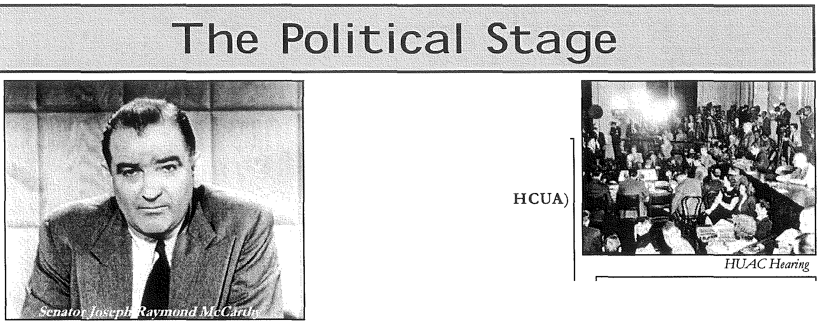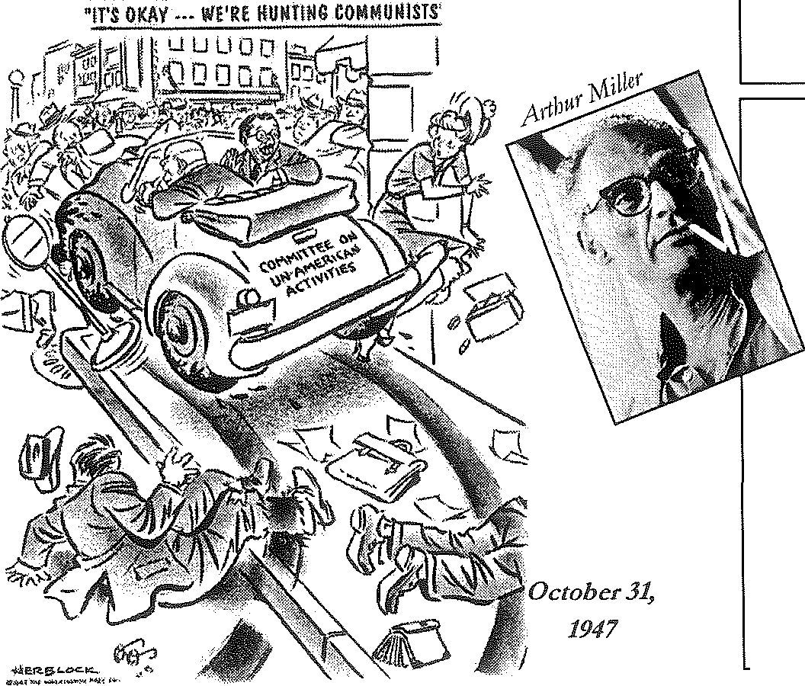on Broadway on January 22, 1953, audiences were well aware of the symbolism it represented. McCarthyism took place during a period of intense suspicion in the United States primarily from 1950 to 1954, when the U.S. government was actively countering alleged American Communist Party subversion, its leadership, and others suspected of being Communists or sympathizers. During this period people from all walks of life, but especially the arts, became the subject of aggressive "witch-hunts," often based on questionable evidence. Paranoia reached a peak of hysteria.
mittee. August 7, 1958, by the U.S.
Court of Appeals.

Arthur Miller: Certain processes are universaL When Gentiles in Hitler's Germa1!J, for example, saw their Jewish neighbors being trucked riff, or soldiers in Soviet Ukraine saw the Kulaks sing before their ryes, the common reaction, even among those unsympathetic to Nazism or Communism, was
quite natural!J to turn awqy in fear if being identified with the
condemned As I learned from non-Jewish refugees, however, there was often a despairing piry mixed with 'Well, thry
must have done something. '

In the filin industry alone, over
300 actors, writers and directors were denied work in the U.S. through the informal Hollywood
blacklist. The studios, after flrst resisting, agreed to submit artists' names to the House Committee for "clearing" before employing them. "This unleashed a veritable hojy terror," wrote Arthur Miller. Even Miller's
close friend, filin director Elia Kazan, 'named names' to the HUAC, effectively ending a friendship, careers, and in some cases, lives. Miller and writer Lillian Hellman pub­ licly denounced him.

lllllruiEIII I.liEIIIIII

This site provides a wealth of primary source documents, from trail transcripts to rare books and histori­ cal maps of Salem Village. Also features a helpful Q&A with the town archivist for Danvers (formerly Salem Village).

http:/ /www.riveib.com/thoughts/puritan/puritan.html
This site contains Mary Easty's petition to the court asking them to please not shed any more innocent blood. The site also contains background historical information on the trials.

Find a chronology of events, images, select trail transcripts and petitions, biographies, excerpts from Cot­
ton Mather's Memorable Providences and more...

http:/ /ww'vv.salemweb.com/witches.html
This site contains a brief historical introduction to the events of 1692-93 in Salem. This site also contains various links to more specific aspects of Salem and the trials.

This site answers some commonly asked questions about the trials and witchcraft in the seventeenth cen­
tury.

An interactive trip through the hysteria that caused the witch hunt in Salem, offered from the perspective of one of the accused.

An interactive map showing the locations of the accused and the accusers, as well as major roads, rivers, townships and households.

Although over 500 of the original legal documents from the trials still exist, one particular death warrant, known as the Carey Document, has been exposed as a fake. This site includes information on the discov­ ery of the document with pictures.

Peoples of the Wabanaki Indian Confederacy, with links to information about each Wabanaki nation and its language.

h.rrp: /I religiousmovemen ts.lib.vin>inia.eflu/ nrms / s:dem.html
A chronology of important events surrounding the Salem witch trials.

